A000-US-SD-Lakota-Ghost Dancer-1890

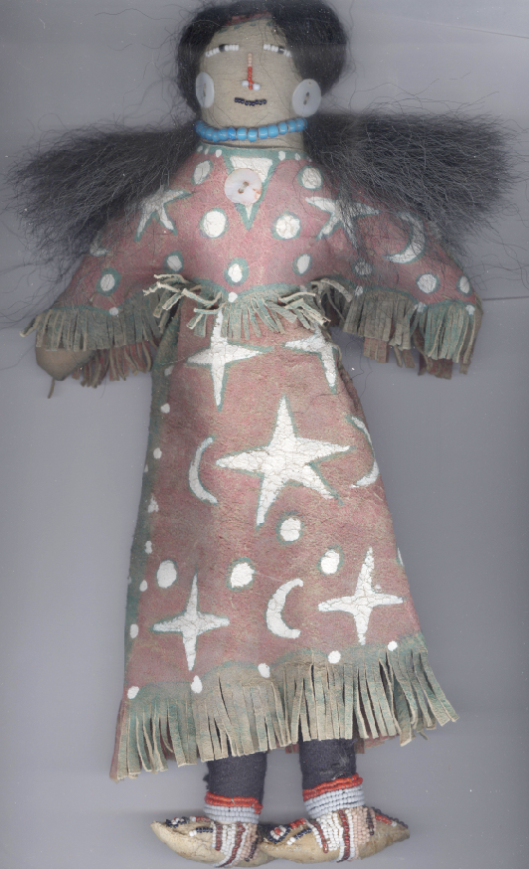

Figs. 1-2. US-SD-Lakota-Ghost Dancer-1890.

**Case No.: 12**

**Accession No.**

**Formal Label:** US-SD-Lakota-Ghost Dancer-1890

**Display Description:**

Ghost Dance Doll, *A-nog-i-te*, “Double-faced woman,” Lakota Sioux Doll from Chamberlain, South Dakota. *A-nog-i-te* is the wife of *Tate* (Wind) and daughter of *Skan* (Sky). Her name reflects her two faces; one beautiful, the other ugly, a punishment for her attempt to seduce *Wi* (Sun). In other Lakota tales she is the bringer of "quilling," the craft of sorting and dyeing porcupine quills. Here she wears the clothing of the Ghost dance. In this guise the “ugly” visage reflects the duality of the Lakota being saddened of the period before the appearance of the Messiah when the white man destroyed the buffalo and the ancient lifeways. The other face is gladdened by the period after the appearance of the Messiah when the buffalo and the ancient lifeways were restored. Ghost Dance dresses and shirts were promoted by the Lakota as embodying their personal apocalyptic dream visions incorporating symbols of the morning four-pointed star, the evening polaris five-pointed star, the crescent moon and the circular sun that would make the wearer a harbinger of the new earth and impervious to the destruction by the white man. These dolls were ceremonial in nature and used to invoke the fruit of these visions. **LC Classification:**

**Date or Time Horizon: 1890**

**Geographical Area: Chamberlain, SD**

**Map:**

**GPS coordinates:**

**Cultural Affiliation: Lakota**

**Media:**

While the bead work is identical on both sides it is done in different colors. The full brain-tanned dress is hand painted with earth paints with some flaking. Body has trade cloth leggings. Upper body is canvass. , Painted on both sides, Seed bead face with horse hair, hair. Has beaded moccasins. Doll necklaces has blue white hart beads and ear pieces are pearl shell buttons.

It is made of native-tanned hide paint on old white muslin body. It has red trade cloth leggings, seed beaded face with beaded necklace. Trade beaded belt, conch shell earrings and conch shell buttons on the leggings and last seed beaded moccasins.

**Dimensions: H 12 in**

**Weight:**

**Condition: original**

**Provenance: old collection, Chamberlain, SD**

**Discussion:**

The Ghost Dance was first instituted in 1889 by the Northern Paiute spiritual leader Wovoka c 1856 - September 20, 1932) who invoked the ancient circle dance to reunite the living tribal members with spirits of the dead. The latter were beseeched to fight on behalf of the living and to cause European immigrants to leave the areas of First Nations’ lands. The objective was to end the racism of the Dawes Act of 1887 and to usher in an era of peace and prosperity among First Nations. The Dawes Act authorized the President of the United States to divide First Nations’ tribal land into personal allotments in order to destroy tribal identities. This culminated in the Wounded Knee Massacre of December 1890, in which the U S Army murdered 153 Lakota of the Miniconjou and Hunkpapa sub-groups.

The Lakota variation on the Ghost Dance is represented by this Circle Dancer. She is seen on one side as joyful, expectant of the new millennium in which Lakota people will live in peace and prosperity. On the obverse she is seen as grim, a testimony to the possibility that the Lakota will continue to suffer under the U S Government’s laws of assimilation.

**References:**

Du Bois, Cora Alice. 2007. [*The 1870 ghost dance*](http://www.worldcat.org/title/1870-ghost-dance/oclc/978023187&referer=brief_results). Lincoln: University of Nebraska Press.

Osterreich, Shelley Anne. 1991. [*The American Indian ghost dance, 1870 and 1890: an annotated bibliography*](http://www.worldcat.org/title/american-indian-ghost-dance-1870-and-1890-an-annotated-bibliography/oclc/23144783&referer=brief_results). New York: Greenwood Press, 1991. [Andersson, Rani-Henrik. 2013. *Lakota ghost dance of 1890*.](http://www.worldcat.org/title/lakota-ghost-dance-of-1890/oclc/815824895&referer=brief_results) Univ Of Nebraska Press.

Appendix: original description

